Day 20 - 104608492 - Shirisha Perapagu

OOAD

Object Oriented paradigm, Design Patterns, Design Workflow, Refactoring

Task1

SRP Violation and Implementation

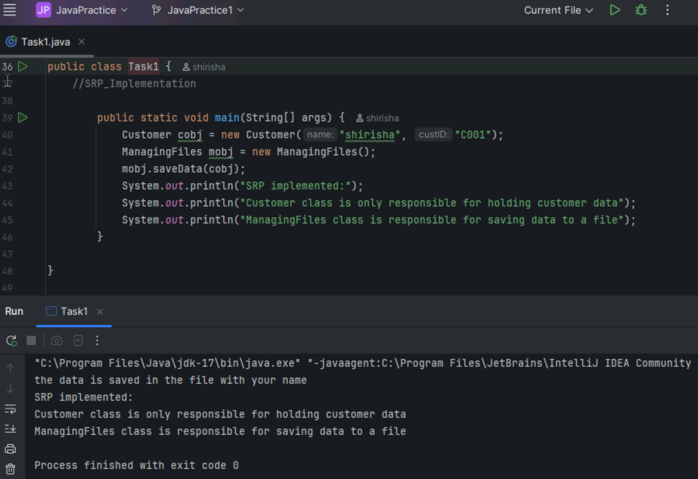

Task2

OCP Violation and implementation

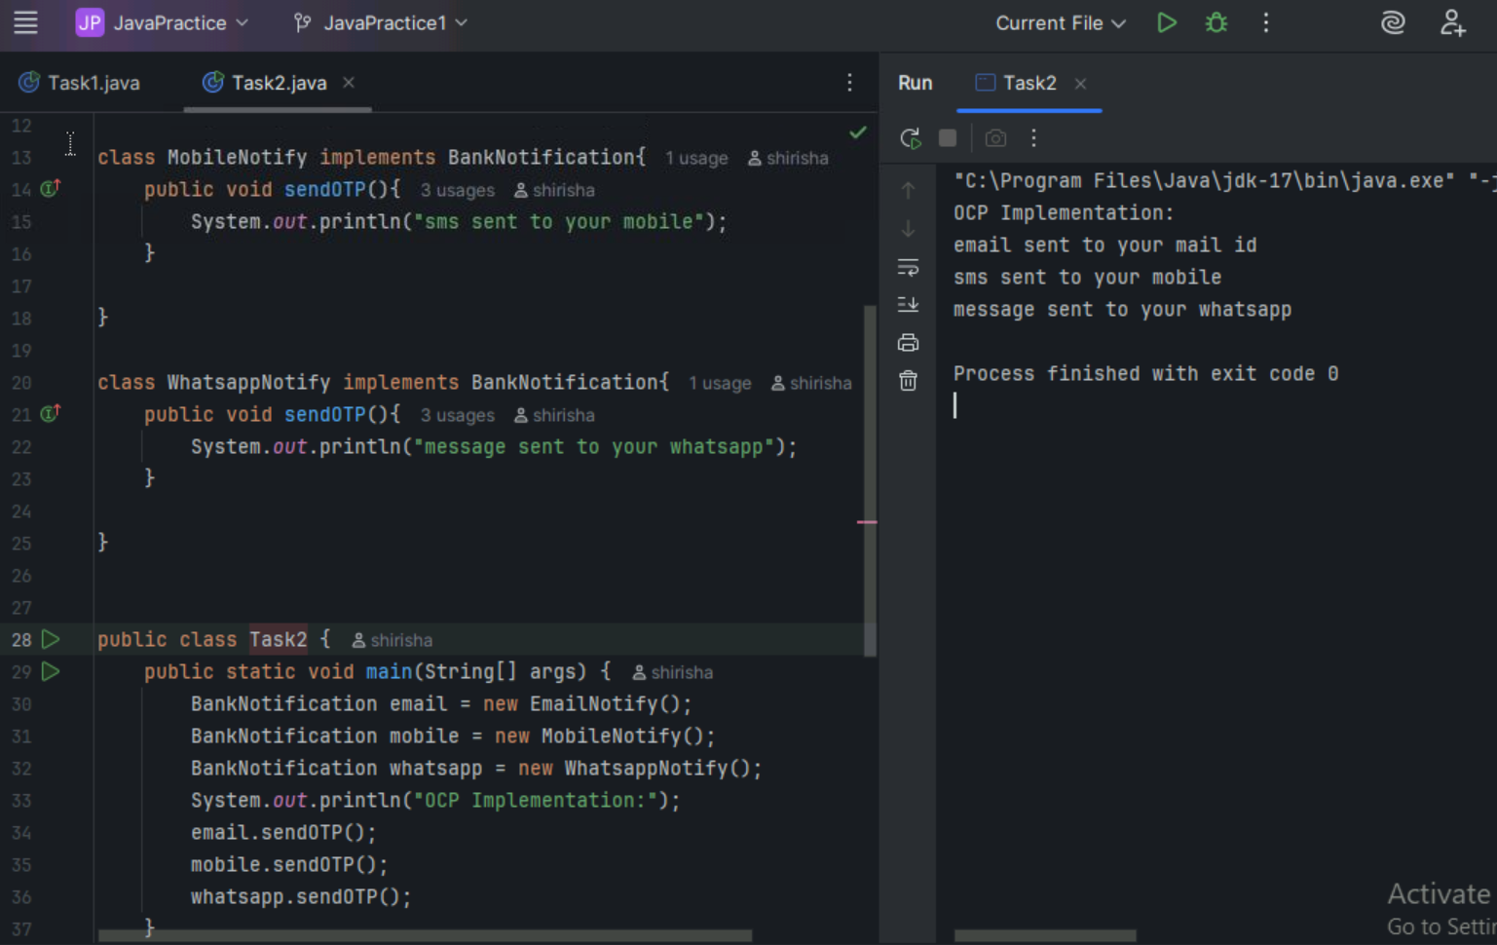

Task 3 SRP Violation and Implementation – Book Example

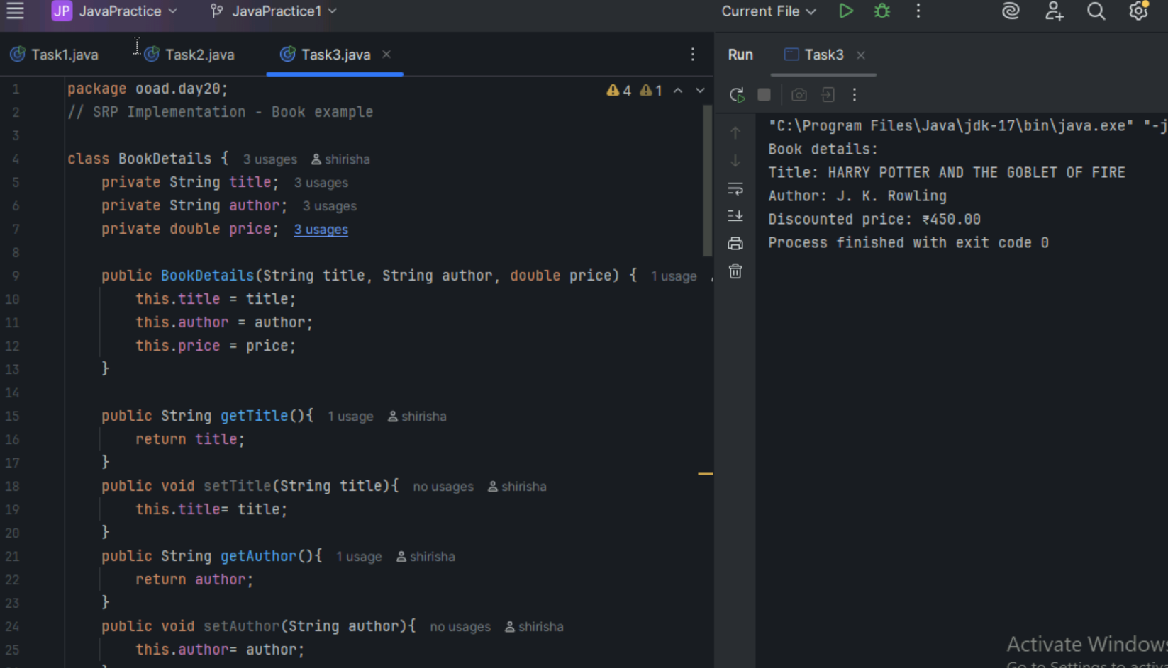

Task 4 SRP Violation and Implementation – Employee Report Generation

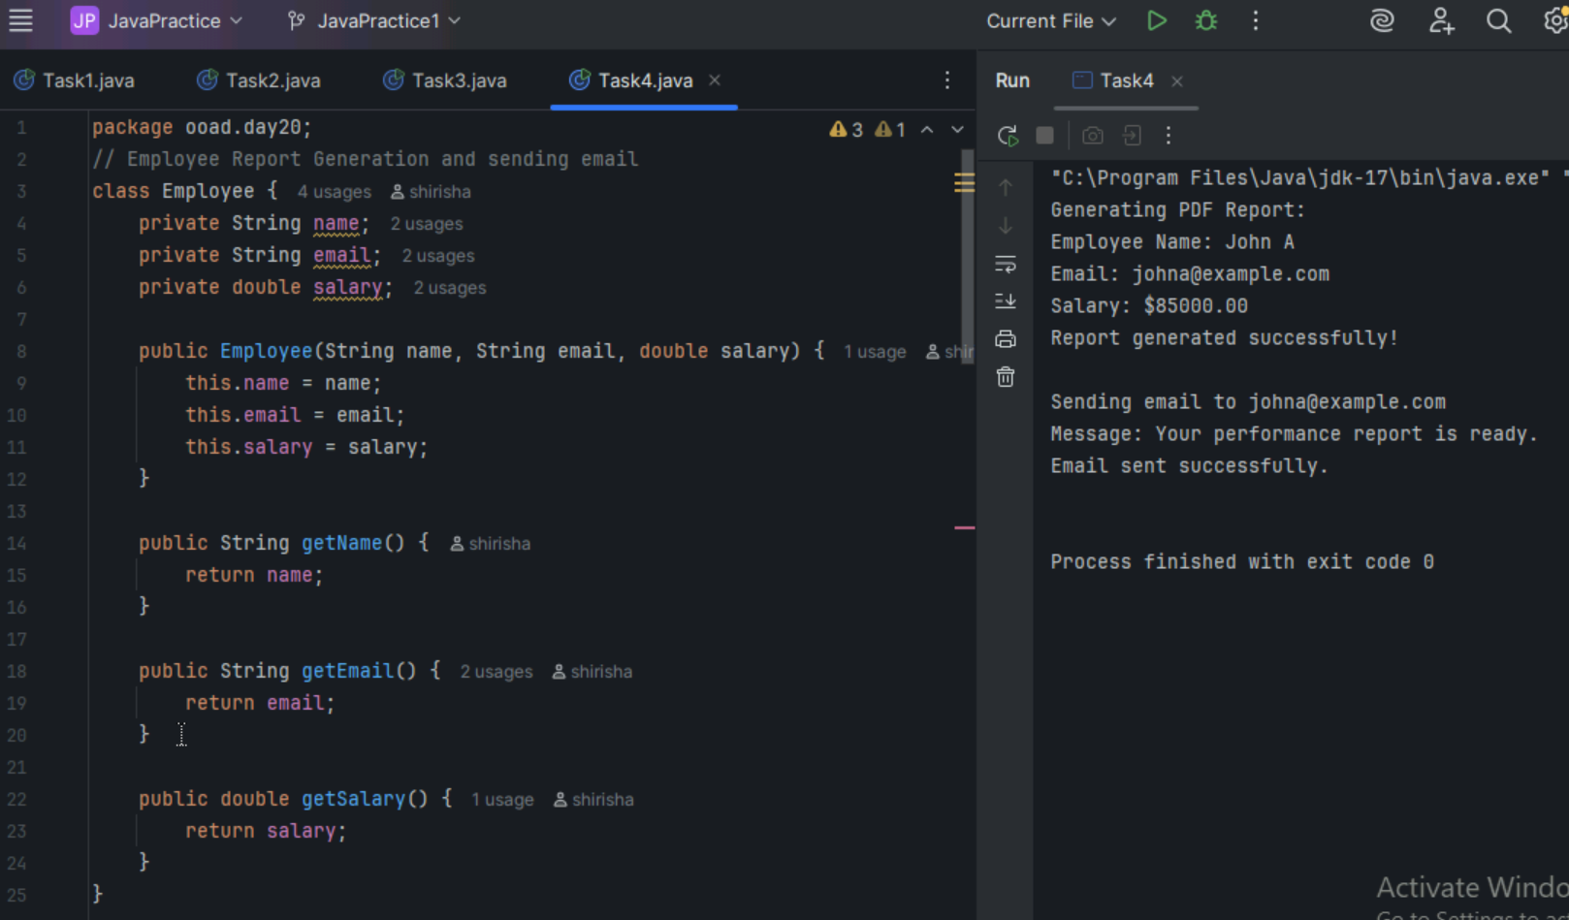

Task 5 OCP Violation and implementation – Shapes Area Comparison

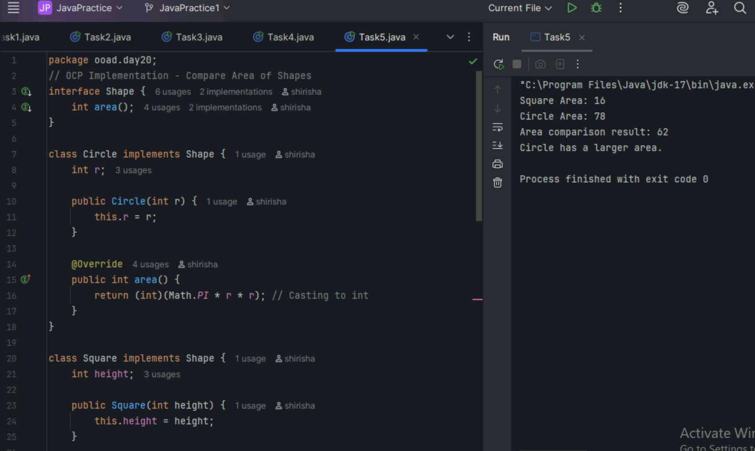

Task 6

Create Structural Diagrams

1. Class Diagram

Syntax Example

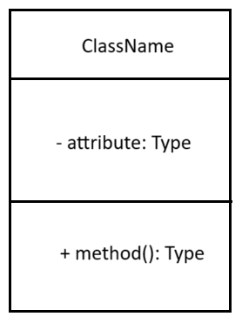 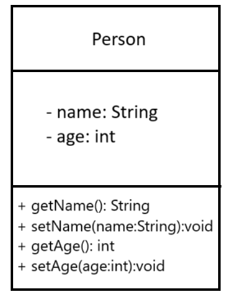

1. Object Diagram

Syntax Example

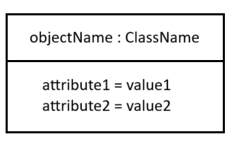 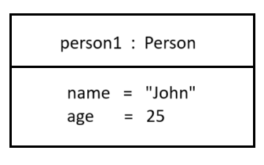

1. Component Diagram

Syntax

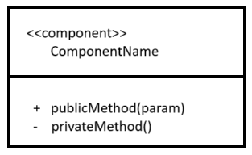

Example

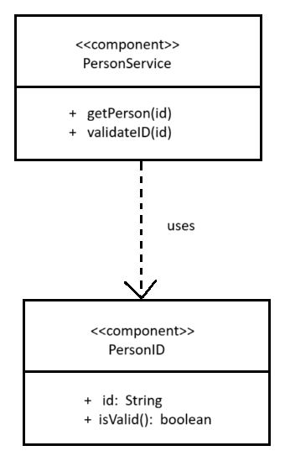

1. Package Diagram

Syntax

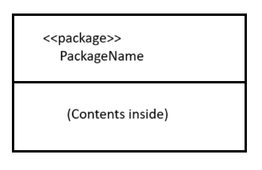

Example

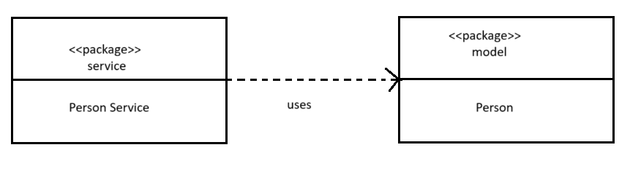

1. Composite structure Diagram

Syntax

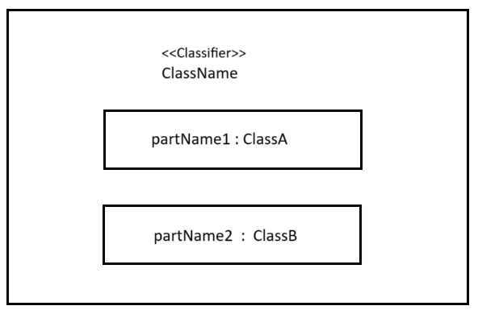

Example

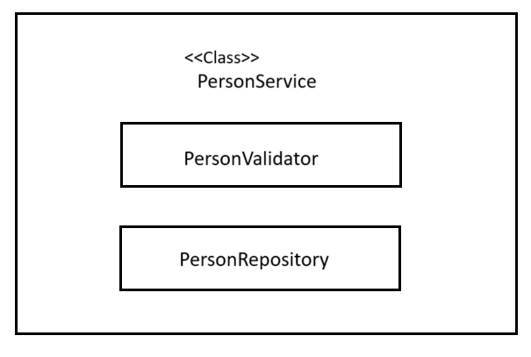

1. Deployment Diagram

Syntax

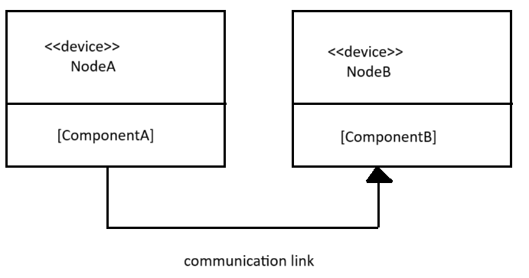

Example

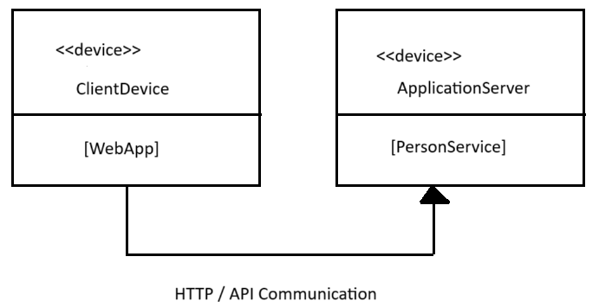

Home Task 7

Wap to create a class Student.. With 3 methods

registrationDetails(), marksCalc(), feesCalc()

